INJURY EVALUATION
On this diagram mark where your pain is:
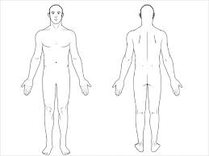

***Weight: _________ Height: __________***
For each, circle what BEST applies:
- The pain is: OCCASIONAL INTERMITTENT CONSTANT
- The pain is: DULL SHARP ACHY THROBBING BURNING STABBING
Circle ALL symptoms that apply:
CATCHING POPPING LOCKING GRINDING SWELLING STIFFNESS
INSTABILITY WEAKNESS TINGLING NUMBNESS NIGHT PAIN OTHER: ___________________________________

When is your pain worse? _________________________________________________________________________________

What makes it better? ____________________________________________________________________________________

What makes it worse? ____________________________________________________________________________________

Have you ever experienced any injury to or symptoms involving this body part in the past? Yes / No
Provide Details: _________________________________________________________________________________________

______________________________________________________________________________________________________

What tests have you had regarding this injury? None: ______ X-Rays: _______ MRI: ______ CT Scan: _____ EMG/NCV: ______

Have you had any treatment for this injury? None: ________ Medications: ______ Therapy: ______________
Surgery: ______ Injections: ________ Pain Management: ______
Other: _______________________________________________

Was any of the treatment effective, explain? __________________________________________________________________

______________________________________________________________________________________________________
The above information is true to the best of my knowledge. I authorize my insurance benefits be paid directly to the physician. I understand that I am financially responsible for any balance. I also authorize Dr. Lawrence Lenderman or my insurance company to release any information required to process my claims.

__________________________________________________ ____________________________________
SIGNATURE DATE

